**Nambu Matrix Method**

The eigenstress is defined as:

$$σ_{nm}^{0}=C_{nmkl}ε_{kl}^{0}=C_{nm11}ε_{11}^{0}+C_{nm12}ε_{12}^{0}+C_{nm13}ε_{13}^{0}+C_{nm21}ε_{21}^{0}+C_{nm22}ε_{22}^{0}+C_{nm23}ε_{23}^{0}+C_{nm31}ε_{31}^{0}+C_{nm32}ε_{32}^{0}+C_{nm33}ε_{33}^{0}=C_{nm11}\left(Q_{11}P_{1}^{2}+Q_{12}\left(P_{2}+P_{3}\right)\right)+C_{nm12}ε_{12}^{0}\left(Q_{44}P_{1}P_{2}\right)+C_{nm13}ε_{13}^{0}\left(Q_{44}P_{1}P_{3}\right)+C_{nm21}ε_{21}^{0}\left(Q_{44}P_{1}P_{2}\right)+C_{nm22}ε_{22}^{0}\left(Q_{11}P_{2}+Q_{12}\left(P_{3}+P_{1}^{2}\right)\right)+C_{nm23}ε_{23}^{0}\left(Q_{44}P_{2}P_{3}\right)+C_{nm31}ε_{31}^{0}\left(Q_{44}P_{1}P_{3}\right)+C_{nm32}ε_{32}^{0}\left(Q_{44}P_{2}P_{3}\right)+C_{nm33}ε_{33}^{0}\left(Q_{11}P_{3}+Q_{12}\left(P_{1}^{2}+P_{2}\right)\right)$$

$$Q_{11}=\frac{C_{11}q_{11}+C_{12}q_{11}-2C_{12}q_{12}}{C_{11}^{2}+C_{11}C_{12}-2C_{12}^{2}}$$

$$Q_{12}=\frac{C_{11}q_{12}-C_{12}q_{11}}{C_{11}^{2}+C_{11}C_{12}-2C_{12}^{2}}$$

We arrive at:

$$σ_{11}^{0}=q_{11}P_{1}^{2}+q_{12}P_{2}^{2}+q_{12}P_{3}^{2}$$

$$σ_{22}^{0}=q_{12}P_{1}^{2}+q_{11}P_{2}^{2}+q_{11}P_{3}^{2}$$

$$σ_{33}^{0}=q_{12}P_{1}^{2}+q_{12}P_{2}^{2}+q_{11}P_{3}^{2}$$

$$σ_{13}^{0}=q_{44}P_{1}P_{3}$$

$$σ_{23}^{0}=q_{44}P_{2}P_{3}$$

$$σ_{12}^{0}=q_{44}P_{1}P_{2}$$

$$σ_{ij}^{0}=q_{ijkl}P_{k}P_{l}$$

$$q_{11}=q_{1111}=q_{2222}=q_{3333},q_{12}=q_{1122}=q_{1133},q_{44}=2q_{1212}=2q_{1313}$$

$$q_{ijkl}=q_{ijlk}=q_{jikl}=q_{klij}$$

$q$ is the electrostriction tensor.

Let us now solve the mechanical equilibrium equation using the identity $C_{ijkl}ε_{kl}^{0}=σ_{ij}^{0}.$

$$C_{ijkl}ε_{kl,j}=C_{ijkl}ε_{kl,j}^{0}=σ_{ij,j}^{0}$$

For an anisotropic cubic material,

$$C_{11}=C_{1111}=C_{2222}=C_{3333},C_{12}=C_{1122}=C_{1133},C_{44}=C_{1212}=C_{1313}$$

$$C_{ijkl}=C_{ijlk}=C_{jikl}=C_{klij}$$

All other elastic tensor values, other than the given $C_{11},C_{12}, C_{44}$ are zero. Therefore,

$$C_{ijkl}ε_{kl,j}=C_{11}ε_{1,11}+C_{12}ε_{22,1}+C_{12}ε_{33,1}+C_{44}ε_{21,2}+C_{44}ε_{31,3}+C_{44}ε_{12,2}+C_{44}ε_{13,3}$$

In the following derivation, we abandon the repeated index tensor summation notation. Repeated indices do **NOT** imply summation. Explicit summation symbols will be used instead. Subscripted commas still refer to partial differentiation.

$$C_{ijkl}ε_{kl,j}=\left(C_{11}-C_{12}\right)ε_{ii,i}+C_{12}\sum_{j}{ε_{jj,i}}+2C_{44}\sum_{j\left(≠i\right)}{ε_{ij,j}}=\left(C_{11}-C_{12}-2C_{44}\right)ε_{ii,i}+C_{12}\sum_{j}{ε_{jj,i}}+2C_{44}\sum_{j}{ε_{ij,j}}$$

$$ε_{ij}=\frac{1}{2}\left(\frac{∂u_{i}}{∂x_{j}}+\frac{∂u_{j}}{∂x_{i}}\right)$$

Let us 3D Fourier Transform the entire equation:

$$F_{3D}\left\{\sum_{j}{σ_{ij,j}^{0}}=\left(C_{11}-C_{12}-2C_{44}\right)ε_{ii,i}+C_{12}\sum_{j}{ε_{jj,i}}+2C_{44}\sum_{j}{ε_{ij,j}}\right\}$$

$$\sum_{j}{iξ_{j}{\hat{σ}}_{ij}^{0}}=iξ_{i}\left(C_{11}-C_{12}-2C_{44}\right){\hat{ε}}_{ii}+C_{12}\sum_{j}{iξ_{i}{\hat{ε}}_{jj}}+2C_{44}\sum_{j}{iξ_{j}{\hat{ε}}_{ij}}$$

Using our definition of the displacement field:

$${\hat{ε}}_{ij}=\frac{1}{2}\left(iξ_{j}{\hat{u}}_{i}+iξ_{i}{\hat{u}}_{j,i}\right)$$

$$\sum_{j}{iξ_{j}{\hat{σ}}_{ij}^{0}}=-ξ_{i}^{2}\left(C_{11}-C_{12}-2C_{44}\right){\hat{u}}_{i}-C_{12}\sum_{j}{ξ_{i}ξ_{j}{\hat{u}}_{j}}-C_{44}\sum_{j}{\left(ξ_{j}^{2}{\hat{u}}_{i}+ξ_{i}ξ_{j}{\hat{u}}_{j}\right)}$$

$$\sum_{j}{iξ_{j}{\hat{σ}}_{ij}^{0}}=-ξ_{i}^{2}\left(C_{11}-C_{12}-2C_{44}\right){\hat{u}}_{i}-\sum_{j}{\left(\left(C_{12}+C_{44}\right)ξ_{i}ξ_{j}{\hat{u}}_{j}+C_{44}ξ_{j}^{2}{\hat{u}}_{i}\right)}$$

$$\sum_{j}{iξ_{j}{\hat{σ}}_{ij}^{0}}=-ξ_{i}^{2}\left(C_{11}-C_{12}-2C_{44}\right){\hat{u}}_{i}-\sum_{j}{\left(C_{12}+C_{44}\right)ξ_{i}ξ_{j}}{\hat{u}}_{j}-\sum_{j}{C_{44}ξ_{j}^{2}{\hat{u}}_{i}}$$

$$\sum_{j}{C_{44}ξ_{j}^{2}{\hat{u}}_{i}}=C_{44}{\hat{u}}_{i}\sum_{j}{ξ_{j}^{2}}=C_{44}{\hat{u}}_{i}{\left|\vec{ξ}\right|}^{2}$$

$$\sum_{j}{iξ_{j}{\hat{σ}}_{ij}^{0}}+ξ_{i}^{2}\left(C_{11}-C_{12}-2C_{44}\right){\hat{u}}_{i}+\sum_{j}{\left(C_{12}+C_{44}\right)ξ_{i}ξ_{j}}{\hat{u}}_{j}+C_{44}{\hat{u}}_{i}{\left|\vec{ξ}\right|}^{2}=0$$

Dividing both sides by: ${\left|\vec{ξ}\right|}^{2}$ and defining $\hat{ξ}=\frac{ξ}{\left|\vec{ξ}\right|}$

$$\frac{i}{\left|\vec{ξ}\right|}\sum_{j}{{\hat{ξ}}_{j}{\hat{σ}}_{ij}^{0}}+\left[{\hat{ξ}}_{i}^{2}\left(C_{11}-C_{12}-2C_{44}\right)+C_{44}\right]{\hat{u}}_{i}+\left(C_{12}+C_{44}\right){\hat{ξ}}_{i}\sum_{j}{{\hat{ξ}}_{j}{\hat{u}}_{j}}=0$$

$$g_{ij}=σ_{ij}^{0}=C_{ijkl}ε_{kl}^{0}=q_{ijkl}P_{k}P_{l}$$

Now we have a matrix equation for the displacement field:

$$\left[{\hat{d}}_{1}{\hat{u}}_{1}+\left(C_{12}+C_{44}\right){\hat{ξ}}_{1}^{2}\right]{\hat{u}}_{1}+\left(C_{12}+C_{44}\right){\hat{ξ}}_{1}{\hat{ξ}}_{2}{\hat{u}}_{2}+\left(C_{12}+C_{44}\right){\hat{ξ}}_{1}{\hat{ξ}}_{3}{\hat{u}}_{3}=-\frac{i}{\left|\vec{ξ}\right|}{\hat{G}}_{1}$$

$$\left(C_{12}+C_{44}\right){\hat{ξ}}_{2}{\hat{ξ}}_{1}{\hat{u}}_{1}+\left[{\hat{d}}_{2}{\hat{u}}_{2}+\left(C_{12}+C_{44}\right){\hat{ξ}}_{2}^{2}\right]{\hat{u}}_{2}+\left(C_{12}+C_{44}\right){\hat{ξ}}_{2}{\hat{ξ}}_{3}{\hat{u}}_{3}=-\frac{i}{\left|\vec{ξ}\right|}{\hat{G}}_{2}$$

$$\left(C_{12}+C_{44}\right){\hat{ξ}}_{3}{\hat{ξ}}_{1}{\hat{u}}_{1}+\left(C_{12}+C_{44}\right){\hat{ξ}}_{3}{\hat{ξ}}_{2}{\hat{u}}_{2}+\left[{\hat{d}}_{3}{\hat{u}}_{3}+\left(C_{12}+C_{44}\right){\hat{ξ}}_{3}^{2}\right]{\hat{u}}_{3}=-\frac{i}{\left|\vec{ξ}\right|}{\hat{G}}_{3}$$

The above equations can be solved for ${\hat{u}}_{i},$ giving [Shinji Nambu <http://www.math.psu.edu/cao/Papers_PDF/Nambu-9-1-94.pdf>]

Computationally, the Nambu method is much faster, using one single calculating. The Khachaturyan method, though more general, requires visiting every grid point because Green’s elastic tensor is k-space dependent, and there is no analytical equation for Green’s elastic tensor, except for $C_{11}-C_{12}-2C_{44}=0$ (isotropy) and $C_{12}+C_{44}=0$.

Given the displacement field, we can calculate the strain as:

$${\hat{ε}}_{ij}=\frac{1}{2}\left(iξ_{i}{\hat{u}}_{j}+iξ_{j}{\hat{u}}_{i}\right)$$

$$ε_{ij}=F_{3D}^{-1}\left\{{\hat{ε}}_{ij}\right\}$$

Using this analytical expression for strain, we can plug back into the elastic energy:

$$F_{relax}^{het}=\int{\frac{1}{2}C_{ijkl}δε_{ij}δε_{kl}-C_{ijkl}ε_{kl}^{0}δε_{ij}}d\vec{x}={\left(2π\right)}^{3}\int{\frac{1}{2}C_{ijkl}{\hat{δε}}_{ij}^{*}{\hat{δε}}_{kl}-{\left(q_{ijkl}{\hat{P}}_{k}{\hat{P}}_{l}\right)}^{*}{\hat{δε}}_{ij}}d\vec{ξ}$$

Nambu has shown that this simplifies to:

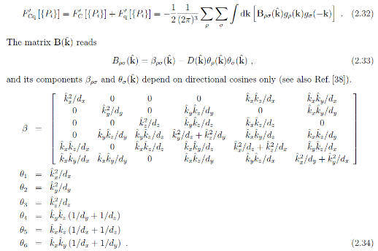

The above expression can be inverse Fourier transformed into:

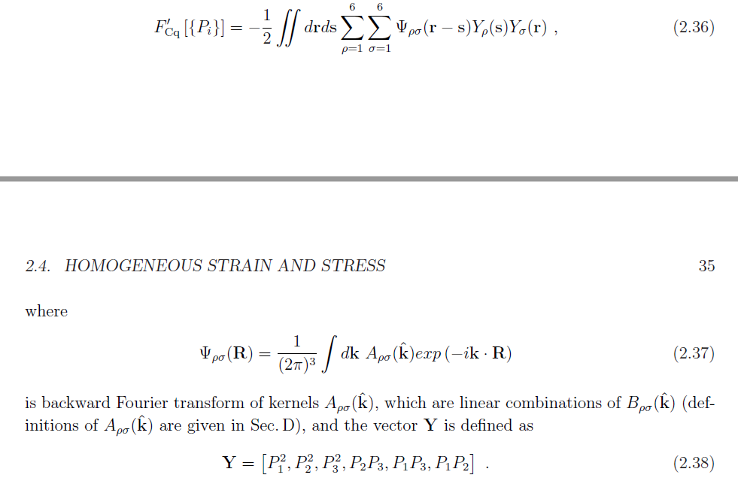



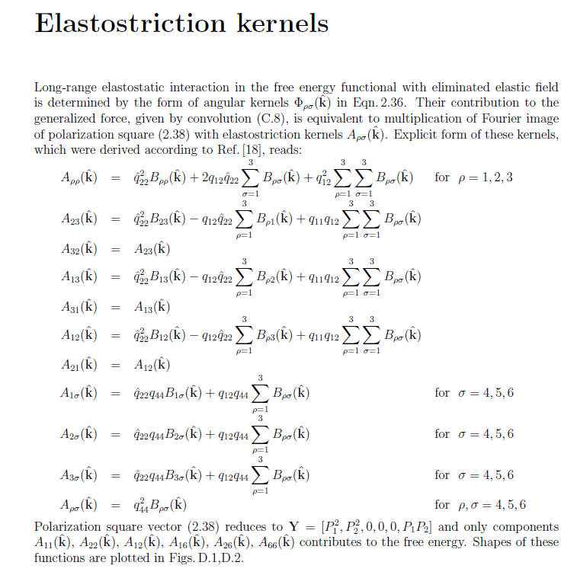

Whose partial derivatives with respect to polarization can be found to be:

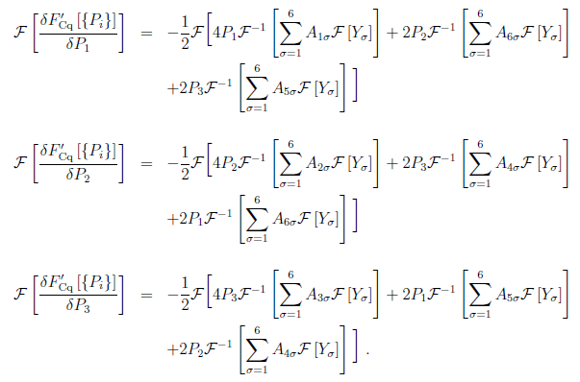

**Heterogeneous Relaxation Energy**

Nambu et al and Pavel Marton show that…

S. Nambu Domain Formation and Elastic Long Range Interaction in Ferroelectric Perovskites

Pavel Marton Application of Elastostatic Green Function Tensor Techniques to Electrostriction in Cubic, Hexagonal, and Orthorhombic Crystals.

**Also called the elastostriction energy.**

$$F_{relax}^{het}=\int{\frac{1}{2}C_{ijkl}δε_{ij}δε_{kl}-C_{ijkl}ε_{kl}^{0}δε_{ij}}d\vec{x}$$

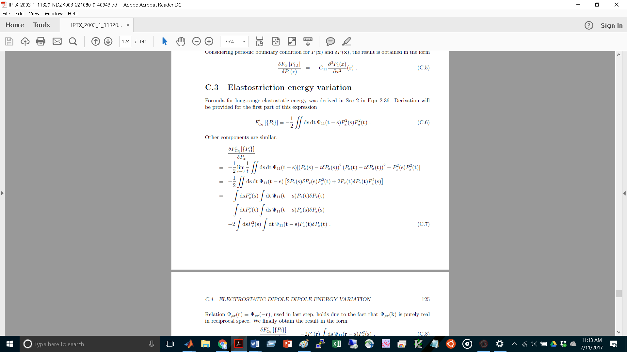

**Our Derivation**

The question now is when we plug the strain back into our elastic strain free energy, we need the variational derivative of free energy with respect to strain for our TD-LGD equation. When we evaluate this variational derivative, should we consider strain as a function of polarization? We derive the variational derivative here:

$$f_{relax}^{het}=\frac{1}{2}C_{ijkl}δε_{ij}δε_{kl}-C_{ijkl}ε_{kl}^{0}δε_{ij}$$

$$\frac{1}{2}C_{ijkl}δε_{ij}δε_{kl}=\frac{1}{2}C_{11}\left(δε_{11}^{2}+δε_{22}^{2}+δε_{33}^{2}\right)+C_{12}\left(δε_{22}δε_{33}+δε_{11}δε_{33}+δε_{11}δε_{22}\right)+2C_{44}\left(δε_{23}^{2}+δε_{13}^{2}+δε_{12}^{2}\right)$$

$$C_{ijkl}ε_{kl}^{0}δε_{ij}=q_{ijkl}P_{k}P_{l}{δε}_{ij}=q_{11}\left(δε_{11}P_{1}^{2}+δε_{22}P_{2}^{2}+δε_{33}P_{3}^{2}\right)+q_{12}\left(δε_{11}\left(P_{2}^{2}+P_{3}^{2}\right)+δε_{22}\left(P_{1}^{2}+P_{3}^{2}\right)+δε_{33}\left(P_{1}^{2}+P_{2}^{2}\right)\right)+2q_{44}\left(δε_{12}P_{1}P_{2}+δε_{13}P_{1}P_{3}+δε_{23}P_{2}P_{3}\right)=\left(q_{11}δε_{11}+q_{12}{δε}_{22}+q_{12}{δε}_{33}\right)P_{1}^{2}+\left(q_{11}{δε}_{22}+q_{12}{δε}_{11}+q_{12}{δε}_{33}\right)P_{2}^{2}+\left(q_{11}δε_{33}+q_{12}{δε}_{11}+q_{12}{δε}_{22}\right)P_{3}^{2}+2q_{44}\left(δε_{12}P_{1}P_{2}+{δε}_{23}P_{2}P_{3}+{εδ}_{13}P_{1}P_{3}\right)$$

In the below derivations, the Einstein notation is not used. Instead summations will be denoted explicitly.

The partial derivative with respect to polarization $\frac{∂}{∂P_{p}}$ commutes with the Fourier transform and inverse Fourier transform operators $F_{3D}$ and .

|  |  |  |  |
| --- | --- | --- | --- |
|  | | | |
|  |  |  |  |
|  |  |  |  |
|  |  |  |  |
|  |  |  |  |

|  |  |  |  |
| --- | --- | --- | --- |
|  | | | |
|  |  |  |  |
|  |  |  |  |
|  |  |  |  |
|  |  |  |  |

|  |  |  |  |
| --- | --- | --- | --- |
|  | | | |
|  |  |  |  |
|  |  |  |  |
|  |  |  |  |
|  |  |  |  |

We can use the inverse Fourier transforms of ${\hat{B}}_{mnp}$ to find $\frac{∂ε_{mn}}{∂P_{p}}$

1) $\frac{∂}{∂P_{o}}\left[\frac{1}{2}C_{11}\left({δε}_{11}^{2}+{δε}_{22}^{2}+{δε}_{33}^{2}\right)\right]=C_{11}\left(δε_{11}\frac{∂δε_{11}}{∂P_{o}}+δε_{22}\frac{∂δε_{22}}{∂P_{o}}+δε_{33}\frac{∂δε_{33}}{∂P_{o}}\right)$

2) $\frac{∂}{∂P_{o}}\left[C_{12}\left(δε_{11}{δε}_{22}+{δε}_{22}δε_{33}+{δε}_{11}δε_{33}\right)\right]=C_{12}\left(δε_{11}\frac{∂δε_{22}}{∂P_{o}}+\frac{∂δε_{11}}{∂P_{o}}δε_{22}+{δε}_{22}\frac{∂δε_{33}}{∂P_{o}}+\frac{∂{δε}_{22}}{∂P_{o}}δε_{33}+δε_{11}\frac{∂δε_{33}}{∂P_{o}}+\frac{∂{δε}_{11}}{∂P_{o}}δε_{33}\right)$

3) $\frac{∂}{∂P_{o}}\left[2C_{44}\left({δε}_{12}^{2}+{δε}_{23}^{2}+{δε}_{13}^{2}\right)\right]=4C_{44}(ε_{12}\frac{∂δε_{12}}{∂P_{o}}+δε_{23}\frac{∂δε_{23}}{∂P_{o}}+δε_{13}\frac{∂δε_{13}}{∂P_{o}})$

1) $\frac{∂}{∂P_{o}}\left[\left(q_{11}δε_{11}+q_{12}{δε}_{22}+q_{12}{δε}_{33}\right)P_{1}^{2}\right]=\left(\frac{∂}{∂P_{o}}\left(q_{11}δε_{11}+q_{12}{δε}_{22}+q_{12}{δε}_{33}\right)\right)P_{1}^{2}+\left(q_{11}δε_{11}+q_{12}{δε}_{22}+q_{12}{δε}_{33}\right)\left(\frac{∂}{∂P_{o}}P_{1}^{2}\right)=\left(q_{11}\frac{∂δε_{11}}{∂P_{o}}+q_{12}\frac{∂{δε}_{22}}{∂P_{o}}+q_{12}\frac{∂{δε}_{33}}{∂P_{o}}\right)P_{1}^{2}+\left(q_{11}δε_{11}+q_{12}{δε}_{22}+q_{12}{δε}_{33}\right)\left(2P_{1}δ_{1o}\right)$

2) $\frac{∂}{∂P_{o}}\left[\left(q_{11}{δε}_{22}+q_{12}{δε}_{11}+q_{12}{δε}_{33}\right)P_{2}^{2}\right]=\left(q_{11}\frac{∂δε_{22}}{∂P_{o}}+q_{12}\frac{∂{δε}_{11}}{∂P_{o}}+q_{12}\frac{∂{δε}_{33}}{∂P_{o}}\right)P_{2}^{2}+\left(q_{11}{δε}_{22}+q_{12}{δε}_{11}+q_{12}{δε}_{33}\right)\left(2P_{2}δ_{2o}\right)$

3) $\frac{∂}{∂P_{o}}\left[\left(q_{11}δε_{33}+q_{12}{δε}_{11}+q_{12}{δε}_{22}\right)P_{3}^{2}\right]=\left(q_{11}\frac{∂δε_{33}}{∂P_{o}}+q_{12}\frac{∂{δε}_{11}}{∂P_{o}}+q_{12}\frac{∂{δε}_{22}}{∂P_{o}}\right)P_{3}^{2}+\left(q_{11}δε_{33}+q_{12}{δε}_{11}+q_{12}{δε}_{22}\right)\left(2P_{3}δ_{3o}\right)$

4) $\frac{∂}{∂P_{o}}\left[2q_{44}\left(δε_{12}P_{1}P_{2}+{δε}_{23}P_{2}P_{3}+{δε}_{13}P_{1}P_{3}\right)\right]=2q_{44}\left(\frac{∂δε_{12}}{∂P_{o}}P_{1}P_{2}+δε_{12}\left(δ_{1o}P_{2}+P_{1}δ_{2o}\right)+\frac{∂δε_{23}}{∂P_{o}}P_{2}P_{3}+δε_{23}\left(δ_{2o}P_{3}+P_{2}δ_{3o}\right)+\frac{∂{δε}_{13}}{∂P_{o}}P_{1}P_{2}+{δε}_{13}\left(δ_{1o}P_{3}+P_{1}δ_{3o}\right)\right)$